Luca Csepely-Knorr

Manchester School of Architecture

**Migge, Leberecht (1881-1935)**

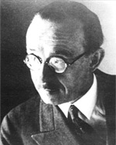

Leberecht Migge

<http://www.stadtentwicklung.berlin.de/denkmal/denkmale_in_berlin/pix/weltkulturerbe/siedlungen/migge_leberecht_150.jpg>

Leberecht Migge started his career as a garden designer, but during the first half of the 20th century he became involved in various questions within the broader field of landscape architecture. His theories synthesised ideas from different professions, and laid the basis for ecological planning.

Migge started his studies in 1899 in the Gardeners’ school in Oranienburg, Germany. After leaving the school in 1902, he started to work in Hamburg at the firm of Jakob Ochs. In the sparkling intellectual life of the hanseatic city he soon became involved in the ‘Garden Reform’ of the beginning of the 20th century, emphasising the importance of German garden traditions in opposition to the English landscape gardens. Migge became a keen advocate of the new gardens, and his designs, such as the Reinhardt Garden in Hamburg-Reinbeck echoed this aim. The ideas of ‘Garden Reform’ did not leave untouched the questions of designing public parks either. It was strongly influenced by the ideas of Werner Hegemann and the example of the American parks and park systems. Migge’s designs for new public parks were based on the idea of turning back to the traditional system of German villages and their open spaces, which are examples of flexible use. His designs were on display during the city planning exhibition in Düsseldorf in 1911, together with the Boston Metropolitan Park system plans by Charles Eliot.

In 1913 he published his book, *Gartenkultur des 20*. *Jahrhunderts* (Garden Culture of the 20th Century) in which he summarised his principles. As well as arguing that all garden types come from utilitarian gardens, he also discussed the questions of urban green areas. In his publication, he set up a typological system of green spaces, and based on this, he evolved a coherent and cohesive green-system idea, thereby merging the discipline of city planning with landscape architecture.

During and after the First World War Migge became more involved in both the theoretical and practical questions of designing urban open spaces. Together with the architect Martin Wagner, who was responsible for urban planning in Berlin, he first designed Jugendparks (Youthparks), with the aim of fulfilling all the functional and recreational needs of public parks, and they later worked on plans for entire sections of cities together. Even in these questions, Migge remained committed to his principles of the need for utilitarian gardens, which under the circumstances of the food shortages after the war, became more and more important. In 1919 he published his pamphlet *Jedermann Selbsversorger* (Everybody Self-Sufficient), in which he argued for a return to nature, and for cities to incorporate plots for every dweller. These aims led him to work on the design of Siedlungen, together with leading modernist architects, such as OTTO HAESLER, ERNST MAY, BRUNO TAUT and his earlier collaborator, Wagner.

**List of works**

1910 Wegmann garden, Rhede, Germany (architect: Hermann Muthesius)

c.1910 Michels silk-weaving factory garden, Germany (architect: Hermann Muthesius)

1913 Hohenhof garden, Germany

1910 Fuhlsbüttel park, Hamburg, Germany

1912-24 Rüstringen park, Wilhelmshaven, Germany

1927-33 Hufeisensiedlung, Berlin-Britz, Germany (with Martin Wagner and Bruno Taut)

**References and further reading**

De Michelis, M. (1991) ‘The Green Revolution: Leberecht Migge and the Reform of the Garden in Modernist Germany’. In Mosser, M. and Teyssot, G. eds. *The History of Garden Design. The Western Tradition from the Renaissance to the Present Day*. London: Thames and Hudson. 409-420.

Haney, D. H. (2007) ‘Leberecht Migge's “Green Manifesto”:Envisioning a Revolution of Gardens’. Landscape Journal. 26. (2) 201-218.

Haney, D. H. (2010) *When Modern was Green. Life and work of landscape architect Leberecht Migge*. London: Routledge.

**Visual material:**

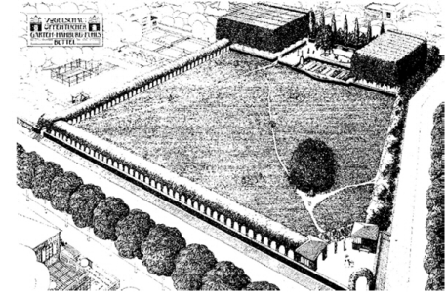

Fuhlsbüttel park, Hamburg, 1909

Copyright:

<http://www.atzebpunkt.de/images/geocaching/wacholder/wacholder_plan_mini.jpg>

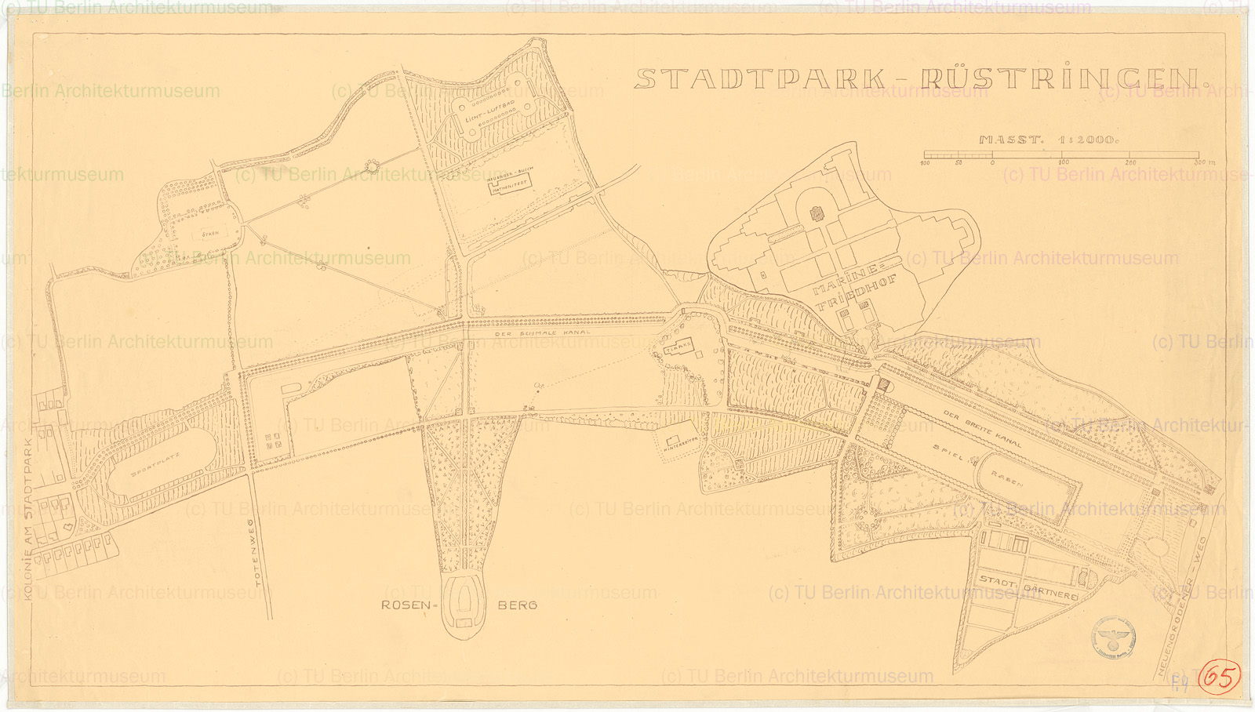

Rüstringen Park

Copyright: [Architekturmuseum der Technischen Universität Berlin](http://www.europeana.eu/portal/search.html?query=europeana_dataProvider%3A%22Architekturmuseum+der+Technischen+Universit%C3%A4t+Berlin+in+der+Universit%C3%A4tsbibliothek%22)

http://architekturmuseum.ub.tu-berlin.de/images/1600WM/IGG%201005.jpg

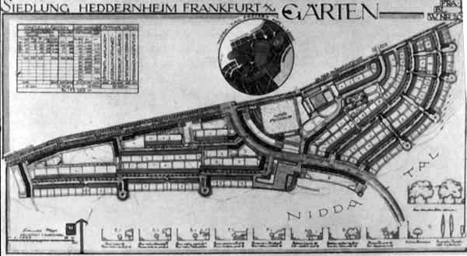

Römerstadt (Heddernheim) Siedlung, end of the 1920s

Gartenschönheit, 1928, p.49.

<http://upload.wikimedia.org/wikipedia/commons/c/cf/Siedlung_Heddernheim_Leberecht_Migge.jpg>

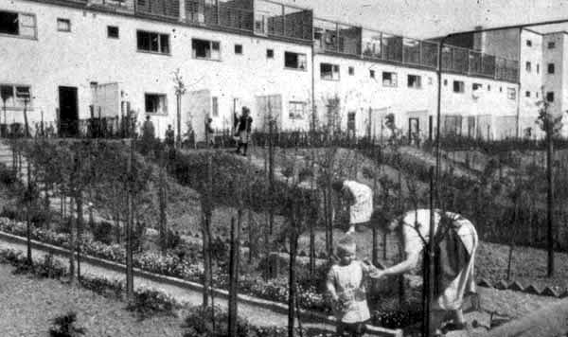

Römerstadt (Heddernheim) Siedlung, end of the 1920s

Copyright:

http://www.tu-cottbus.de/theoriederarchitektur/Wolke/deu/Themen/011/Werner/04a.jpg

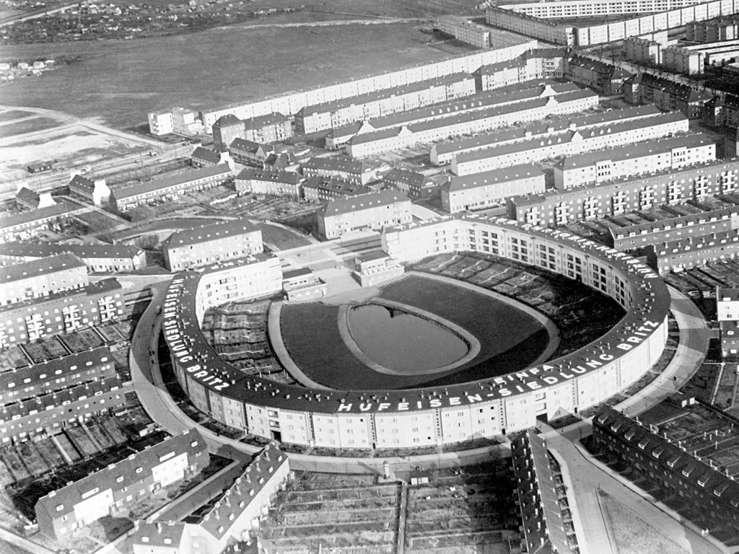

Hufeisensiedlung Berlin-Britz, 1931

Copyright: AKG-Images

https://www.in-die-zukunft-gedacht.de/icoaster/files/hufeisensiedlung_akg_5_b1_w4_1931_1.jpg